BIG DATA CLUSTERING ALGORITHM FOR MITIGATING THE RISK OF CUSTOMER CHURN

A PROJECT REPORT

Submitted by

RAJALAKSHMI. R (Regno. 201306036)
SAKTHI PRIYA. B (Regno. 201306041)
SRIMATHI. R (Regno. 201306055)

in partial fulfillment for the award of the degree
of

BACHELOR OF TECHNOLOGY

in

INFORMATION TECHNOLOGY

DEPARTMENT OF INFORMATION TECHNOLOGY
MEPCO SCHLENK ENGINEERING COLLEGE, SIVAKASI
(An Autonomous Institution affiliated to Anna University Chennnai)

April 2017

BONAFIDE CERTIFICATE

Certified that this project report titled BIG DATA CLUSTERING ALGORITHM FOR MITIGATING THE RISK OF CUSTOMER CHURN is the bonafide work of R.RAJALAKSHMI, B.SAKTHI PRIYA and R.SRIMATHI who carried out the research under my supervision. Certified further, that to the best of my knowledge the work reported herein does not form part of any other project report or dissertation on the basis of which a degree or award was conferred on an earlier occasion on this or any other candidate.

Mrs.M.Blessa Binolin Pepsi, M.E., Dr.T.Revathi, M.E., Ph.D.,

Internal guide Head of the Department
Assistant Professor, Senior Professor,
Department of Information Technology, Department of Information Technology,
Mepco Schlenk Engineering College, Mepco Schlenk Engineering College,
Sivakasi. Sivakasi.

Submitted for viva-Voce Examination held at MEPCO SCHLENK ENGINEERING COLLEGE, SIVAKASI (AUTONOMOUS) on ……………..............

Internal Examiner External Examiner

ACKNOWLEDGEMENT

First and foremost, we thank the almighty for showering grace and blessings on us for making this project a great success.

We extend our sincere gratitude to our college management and our honourable Principal. Dr. S ARIVAZHAGAN, M.E., Ph.D., for providing sufficient working environment such as systems and library facilities. We also thank him very much for providing us adequate lab facilities, which enable us to complete our project.

We would like to extend our heartfelt gratitude to Dr. T. REVATHI, M.E, Ph.d, Professor and Head, Department of Information Technology, Mepco Schlenk engineering college for her valuable guidance and timely encouragements. She put all her valuable experience and expertise in directing, suggesting and supporting us throughout the project to bring out of the best.

We would like to extend our gratitude to Mrs. M. BLESS BINOLIN PEPSI, ME., Assistant Professor, Department of Information Technology, Mepco Schlenk Engineering College for being our Project Coordinator and directing us through our project.

We extend our thanks to all staff members and lab technicians for their moral support in completing our project.

ABSTRACT
ABSTRACT

As market competition intensiﬁes, customer churn management is increasingly becoming an important means of competitive advantage for companies. However, when dealing with big data in the industry, existing churn prediction models cannot work very well. In addition, decision makers are always faced with imprecise operations management. In response to these difﬁculties, a new clustering algorithm called semantic-driven subtractive clustering method (SDSCM) is proposed. Experimental results indicate that SDSCM has stronger clustering semantic strength than subtractive clustering method (SCM) and fuzzy c-means (FCM). Then, a parallel SDSCM algorithm is implemented through a Hadoop Map Reduce framework. In the case study, the proposed parallel SDSCM algorithm enjoys a fast running speed when compared with the other methods. Furthermore, we provide some marketing strategies in accordance with the clustering results and a simpliﬁed marketing activity is simulated to ensure proﬁt maximization.

LIST OF SYMBOLS

LIST OF SYMBOLS

Notation | Description
η | Fuzzy concept
 | € X and is the first centroid in the parameter determination. is the first centroid in SCM.
() | Membership of
 | Sum of absolute difference of (), and is the minimum.
 | Euclidean distance between first cluster centroid and other data points.
 | Neighbour radius
 | Weight coefficient
l | Cycle index
 | Mountain function and is the maximum in the l cycle.
Є | Termination Condition

LIST OF FIGURES

LIST OF FIGURES

Fig No | Fig Name
4.1 | Architecture of the System
4.2 | Flow of the project
6.1 | Execution of parallel SDSCM

CONTENTS

TABLE OF CONTENTS
CONTENTS |  |  | PAGE NO
Bonafide certificate |  |  | Ii
Acknowledgement |  |  | Iii
Abstract |  |  | Iv
List of symbols |  |  | Vi
List of figures |  |  | Ix
CHAPTER 1 |  | INTRODUCTION
 | 1.1 | PROBLEM DESCRIPTION | 2
 | 1.2 | PROJECT OBJECTIVE | 2
CHAPTER 2 |  | LITERATURE REVIEW
 | 2.1 | OVERVIEW | 4
 | 2.2 | FUZZY CLUSTERING ANALYSIS BASED ON AFS THEORY | 4
 | 2.3 | CHURN PREDICTION MODEL IN TELECOM INDUSTRY | 4
 | 2.4 | MAPREDUCE : SIMPLIFIED DATA PROCESSING ON LARGE CLUSTERS | 5
CHAPTER 3 |  | SYSTEM STUDY
 | 3.1 | OVERVIEW | 8
 | 3.2 | PURPOSE | 8
 | 3.3 | SYSTEM REQUIREMENTS | 8
 |  | 3.3.1 HARDWARE REQUIREMENTS | 8
 |  | 3.3.2 SOFTWARE REQUIREMENTS | 8
CHAPTER 4 |  | SYSTEM DESIGN
 | 4.1 | System architecture | 10
 |  | 4.1.1 description | 10
 | 4.2 | PROJECT FLOW | 11
CHAPTER 5 |  | IMPLEMENTATION METHADOLOGY
 | 5.1 | PREREQUISITES | 13
 | 5.2 | ALGORITHMS | 13
 |  | 5.2.1 AXIOMATIC FUZZY SET | 13
 |  | 5.2.2 SUBTRACTIVE CLUSTERING ALGORITHM | 14
 |  | 5.2.3 SECMATIC DRIVEN SUBTRACTIVE CLUSTERING ALGORITHM | 15
 |  | 5.2.4 K-MEANS CLUSTERING | 17
 | 5.3 | CODING | 18
 | 5.4 | SCREENSHOT | 44
CHAPTER 6 |  | Results and Discussion
 | 6.1 | PERFORMANCE ANALYSIS | 45
CONCLUSION |  |  | 47
REFERENCES |  |  | 49

INTRODUCTION

- INTRODUCTION
Expanding the market shares of service industries is the most challenging task now a days. As the competition is fierce, these industries have to pay more attention on the existing customers to avoid customer churn. Customer churn refers to the loss of customers who switch from one company to another competitor within a given period. Industrial practice has shown that customer churn can lead to huge economic losses and even hurt the company’s name. There are existing models to determine customer churn. But they are applicable for small structured data, such as account data and call details’ data, all of which are less than ten thousand records. But now, with the widespread adoption of smart phones and growth in mobile internet, companies today have accumulated unprecedented amounts of data sources. So these industries generate 10.5 trillion user-domain data records, and the corresponding data storage amount is hundreds of terabytes (TB) per day. The huge volume of data has the typical features of big data, and is hence referred to as “telco big data,” which are the data to be analyzed in this project and include call detailed records, Internet trafﬁc logs, user proﬁles, location updates, social networking information and so on.
  - PROBLEM DESCRIPTION
In k-means algorithm, the initial cluster centroids are chosen at random. This leads to maximum number of iterations in the k-means algorithm. Therefore, a new algorithm is introduced to find the relatively good cluster centroid to reduce the number of iterations in k-means algorithm. Semantic Driven Subtractive Clustering Method (SDSCM), a combination of Axiomatic Fuzzy Set algorithm (AFS) and Subtractive Clustering Method (SCM) is introduced in this project.
  - PROJECT OBJECTIVE
The objective of our project is to implement the Semantic Driven Subtractive Clustering Method algorithm. This algorithm is implemented in hadoop environment in map reduce framework. This gives the cluster centroids. These centroids are then passed to k-means algorithm, which gives the clusters.

LITERATURE REVIEW

- LITERATURE REVIEW
  - OVERVIEW
In this section, we have discussed about the existing AFS and SCM algorithms. There are many existing system that uses only the data points and fuzzy concept for clustering. Traditional algorithms the data points were found simply by intuition. The fuzzy concept is implemented based on assumption. The K-Means is used for clustering.
  - FUZZY CLUSTERING ANALYSIS BASED ON AFS THEORY
In current fuzzy theories, the membership functions are often given by personal intuition and the logic operations are implemented by a kind of triangular norms, or shortly t-norm which is chosen beforehand and independent of the original data and facts. The large-scale intelligent systems in real-world applications are usually very large and complex, a containing such a large number of concepts that it is impossible to define the membership functions by personal intuition and to choose suitable one from infinite kinds of triangular norms to implement fuzzy logic systems. In this paper, under the framework of AFS theory, we propose a new algorithmic framework for determining fuzzy sets (membership functions) and their logic operations, which are impersonally and automatically determined by a consistent algorithm according to the original data and facts. The examples will help us reveal and emphasize the main advantages of the new algorithmic framework. In AFS theory, the membership functions and their logic operations are determined by AFS structures and AFS algebra. An AFS structure is a mathematical object of triple which is a special family of combinatory objects, where X is the universe of discourse, M is a set of some simple concepts or attributes on X and t is mathematical abstract of the complex relations containing in the original data and facts such as database, sub preference relations, even descriptions of human intuition. AFS algebra is a family of molecular lattices (i.e., completely distributive lattices) generated by sets such as X, M. Using AFS algebra and AFS structure, a great large number of complex fuzzy concepts on X and their logic operations can be obtained by the proposed algorithm in this paper. The membership functions and their logic operations are more accurate and impersonal reflections of the original data and facts than given by human intuition in other fuzzy theories, and at great extent preserve the information contained in the original data and facts.

  - CHURN PREDICTION MODEL IN TELECOM INDUSTRY
Customer churn prediction is a main feature of in modern telecom communication CRM systems. This research conducts a real-world study on customer churn prediction and proposes the use of boosting to enhance a customer churn prediction model. Unlike most research that uses boosting as a method to boost the accuracy of a given basis learner, this paper tries to separate customers into two clusters based on the weight assigned by the boosting algorithm. As a result, a higher risk customer cluster has been identified. Logistic regression is used in this research as a basis learner, and a churn prediction model is built on each cluster, respectively. The result is compared with a single logistic regression model. Experimental evaluation reveals that boosting also provides a good separation of churn data; thus, boosting is suggested for churn prediction analysis.
  - MAPREDUCE : SIMPLIFIED DATA PROCESSING ON LARGE CLUSTERS
MapReduce is a programming model and an associated implementation for processing and generating large data sets. Users specify a map function that processes a key/value pair to generate a set of intermediate key/value pairs, and a reduce function that merges all intermediate values associated with the same intermediate key. Many real world tasks are expressible in this model, as shown
in the paper. Programs written in this functional style are automatically parallelized and executed on a large cluster of commodity machines. The run-time system takes care of the details of partitioning the input data, scheduling the program’s execution across a set of machines, handling machine failures, and managing the required inter-machine communication. This allows programmers without any experience with parallel and distributed systems to easily utilize the resources of a large distributed system. Our implementation of MapReduce runs on a large cluster of commodity machines and is highly scalable: a typical MapReduce computation processes many terabytes of data on thousands of machines. Programmers find the system easy to use: hundreds of MapReduce programs have been implemented and upwards of one thousand MapReduce jobs are executed on Google’s clusters every day.

SYSTEM STUDY

- SYSTEM STUDY
  - OVERVIEW
System study includes the view of purpose of the project and business context related to the project and main functional requirements needed for doing the project and necessary system requirements installed in the system.
  - PURPOSE
This section discusses the overall flow of our proposed system. Proposed system describes a way to cluster data points with the help of SDSCM algorithm.
The membership functions and their logic operations are determined by original data and facts instead of intuition. Moreover, several simple concepts or attributes can express many complex concepts using AFS algebra and AFS structure.
  - SYSTEM REQUIREMENTS
    - HARDWARE REQUIREMENTS
Operating System : Linux Mint
Hard Disk : 121 GB
RAM : 2 GB
    - SOFTWARE REQUIREMENTS
Framework : Hadoop-2.6.0
HADOOP
The Hadoop is a framework that allows processing large amount of data in a distributed environment. It is designed to improve scalability. It offers large computation and storage facilities. It consists a rich set of libraries for detecting exceptions and failures in the application layer. Hadoop can be single node or multimode cluster. We have used single node cluster in our project. A Hadoop project includes the following modules,
- Hadoop Common: The common utilities that support the other Hadoop modules
- Hadoop Distributed File System (HDFS): A distributed file system that provides high-throughput access to application data.
- Hadoop YARN: A framework for job scheduling and cluster resource management.
- Hadoop Map Reduce: A YARN-based system for parallel processing of large data sets.

SYSTEM DESIGN

- SYSTEM DESIGN
  - SYSTEM ARCHITECTURE

Data and Fuzzy concept
Clustering Results
AFS
SCM
K-means
SDSCM
τ1, τ2

Centroids

Fig 4.1 Architecture of the System

    - DESCRIPTION
AFS :
AFS is an effective way to describe the fuzzy concept. The membership functions and their logic operations are determined by original data and facts instead of intuition. Moreover, several simple concepts or attributes can express many complex concepts using AFS algebra and AFS structure.
SCM :
In SCM, each data point is considered as a potential cluster centroid and the potential is computed as
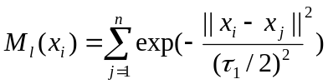
Where 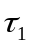 is the neighbor radius, which influences the scope of a cluster centroid. The larger the is, the greater its impact will be. Thus, the data point with maximum mountain function is the first centroid. Then update the mountain function of each data according to the following equation:
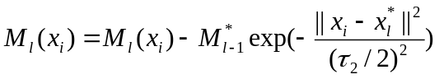
Where 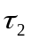 is the influencing weight of the last cluster centroid. Data points near the first cluster centroid will have greatly reduced potential and thus unlikely to be the next cluster centroid.
SDSCM :
1) It can fully express semantic signification of fuzzy concept.
2) It can automatically determine the neighbor radius and the weight coefficient of SCM.
3) It sets a termination condition on the basis of an earlier study reasonably.
KMEANS :
The algorithm of k-means starts with initialized k cluster centroids. Then, data are iteratively assigned to the nearest cluster and the new centroids of k clusters are recalculated until the termination conditions are reached.

  - PROJECT FLOW

START

Input : Telecom Dataset
Perform Semantic Driven Subtractive Clustering Method
Output : Cluster Centroids
Perform clustering
using k-means
STOP
Management Suggestions

Fig. 4.2 Flow of the project

IMPLEMENTATION METHODOLOGY

- IMPLEMENTATION METHODOLOGY
  - PREREQUISITES
The data that are available in the data set are raw data which cannot be used directly for processing. Hence, we need to choose only those attributes which were used to predict the customer churn.
  - ALGORITHMS
    - AFS
The AFS structure established the important relations between EI algebra and EI 2 algebra. By using these classical mathematical objects, a totally new system of fuzzy sets and systems has been established. It is more acceptable for the classical mathematical opinions. We can directly make use of many classical mathematical results. The most important feature is that the system can be operated by computers. In the following, we will show the important fact that any element in the EI algebra over a set M corresponds to a unique fuzzy set from a universe X to the completely distributive molecular lattice EI 3 algebra over X, M and M. We can show that any element in the EI algebra over a set M corresponds to a unique fuzzy set from universe X to w x 0, 1.
    - SDSCM
Step 1:
According to the fuzzy concept ƞ given by the user, compute the membership of 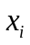.
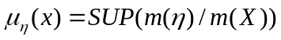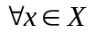
Step 2:
Compute the sum of absolute differences of 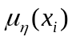.
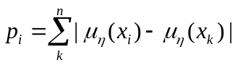
Step 3:
Select the minimum value of 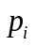 as the first cluster centroid
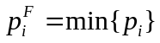
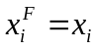
Step 4:
1. Compute the Euclidean distance between the first cluster centroid and other data points.
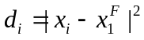
2. Average of 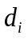, 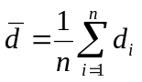
3. Calculate the neighbor radius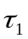
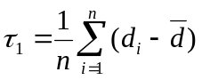
Step 5:
Set the weight coefficient.
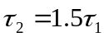
Step 6:
Let l=1 and compute the mountain function of .
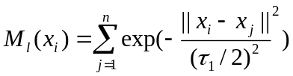
Step 7:
Select the maximum mountain function
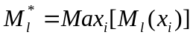
Make the first cluster centroid
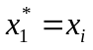
Step 8:
Let l=l+1, and update the mountain function of each data vector
Step 9:
Select the data associated with larger 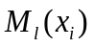 to be the second centroid and execute Step6 repeatedly until
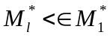
is satisfied. ε is a positive constant less than 1. When the ratio is smaller than ε, the iteration stops.

    - KMEANS
K-means algorithm iteratively minimizes the distances between every data point and its centroid in order to find the most optimal solution for all the data points.
- Random points of the data set are chosen to be centroids.
- Distances between every data point and the centroids are calculated and stored.
- Based on distance calculates, each point is assigned to the nearest cluster
- New cluster centroid positions are updated: similar to finding a mean in the point locations
- If the centroid locations changed, the process repeats from step 2, until the calculated new center stays the same, which signals that the clusters' members and centroids are now set.
Finding the minimal distances between all the points implies that data points have been separated in order to form the most compact clusters possible, with the least variance within them. In other words, no other iteration could have a lower average distance between the centroids and the data points found within them.
  - CODING
SDSCM:
Step 1:
import java.io.IOException;
import java.util.*;
import org.apache.hadoop.fs.Path;
import org.apache.hadoop.conf.*;
import org.apache.hadoop.io.*;
import org.apache.hadoop.mapreduce.*;
import org.apache.hadoop.mapreduce.lib.input.FileInputFormat;
import org.apache.hadoop.mapreduce.lib.input.TextInputFormat;
import org.apache.hadoop.mapreduce.lib.output.FileOutputFormat;
import org.apache.hadoop.mapreduce.lib.output.TextOutputFormat;
public class Mu1{
public static class TokenizerMapper extends Mapper<Object, Text, Text, FloatWritable>{
private static int count=0;
/*
input: dataset
*/
public void map(Object key, Text value, Context context) throws IOException, InterruptedException {
String line = value.toString();
String[] w=line.split(" ");
int a=0,b=0,c=0;
int s=0;
Integer a1,b1,c1;
a1=Integer.valueOf(w[0]);
b1=Integer.valueOf(w[2]);
c1=Integer.valueOf(w[4]);
a=a1.intValue();
b=b1.intValue();
c=c1.intValue();
s=a+b+c;
Integer s1=new Integer(s);
float sf=s1.floatValue();
count++;
context.write(new Text(String.valueOf(sf+count)), new FloatWritable((float) count));
}
}
/*
output:
key: sum+ number
value: number
*/
public static class IntSumReducer extends Reducer<Text,FloatWritable,Text,FloatWritable> {
public static int c=24;
public static float c1=0;
public void reduce(Text key, Iterable<FloatWritable> values,Context context) throws IOException, InterruptedException {
c--;
c1++;
FloatWritable cf=new FloatWritable((float)(c/24.0f));
// to calculate the m(n) lowest value
String kw=key.toString();
String[] w=kw.split(" ");
float k1=Float.valueOf(w[0]);
k1=k1-c1;
context.write(new Text(String.valueOf(k1)),cf);
}
}
/*
output:
key: xsum
value: mu
*/

public static void main(String[] args) throws Exception {
Configuration conf = new Configuration();
Job job = Job.getInstance(conf, "Mu");
job.setJarByClass(Mu1.class);
job.setMapperClass(TokenizerMapper.class);
job.setCombinerClass(IntSumReducer.class);
job.setReducerClass(IntSumReducer.class);
job.setOutputKeyClass(Text.class);
job.setOutputValueClass(FloatWritable.class);
FileInputFormat.addInputPath(job,new Path(args[0]));
FileOutputFormat.setOutputPath(job, new Path(args[1]));
System.exit(job.waitForCompletion(true) ? 0 : 1);
}
}

Step 2 to Step 5:
import java.io.IOException;
import java.util.*;
import java.lang.*;
import java.util.*;
import java.io.RandomAccessFile;
import org.apache.hadoop.io.IntWritable;
import org.apache.hadoop.fs.Path;
import org.apache.hadoop.conf.*;
import org.apache.hadoop.io.*;
import org.apache.hadoop.mapreduce.*;
import org.apache.hadoop.mapreduce.lib.input.FileInputFormat;
import org.apache.hadoop.mapreduce.lib.input.TextInputFormat;
import org.apache.hadoop.mapreduce.lib.output.FileOutputFormat;
import org.apache.hadoop.mapreduce.lib.output.TextOutputFormat;
public class Tou1 {
public static class TokenizerMapper extends Mapper<LongWritable,Text, IntWritable, FloatWritable>{
public static float di=0.0f;
public static int index=0;
/*
input:
key: xsum
value:mu
*/
public void map(LongWritable key, Text value, Context context) throws IOException, InterruptedException {
String a,b;
float min=10000.0f;
float s1=0.0f;
int cluster=0;

RandomAccessFile areader=new RandomAccessFile("/home/hadoop/hadoop/project/tou/mu.txt","r");
RandomAccessFile breader=new RandomAccessFile("/home/hadoop/hadoop/project/tou/mu.txt","r");
while(!(a=areader.readLine()).equals(null))
{
float m=Float.valueOf(a);
while(!(b=breader.readLine()).equals(null))
{
float mn=Float.valueOf(b);
float dd=Math.abs(m-mn);
s1=s1+dd;//find the value of p
index++;//cluster centroid id
if(min>s1)
{
min=s1; // (pi(F))
cluster=index;// (xi(F)) first cluster centroid
}
}//breader
breader.seek(0);
}//areader
breader.close();
areader.close();
float min1;
// to calculate di
RandomAccessFile areader1=new RandomAccessFile("/home/hadoop/hadoop/project/tou/xsum.txt","r");
areader1.seek((int)min);
min1=Float.valueOf(areader1.readLine());
areader1.seek(0);
while(!((a=areader1.readLine()).equals(null)))
{
float mn=(Float.valueOf(a));
di=(mn-min1)*(mn-min1);
context.write(new IntWritable(1), new FloatWritable(di));
}
areader1.close();
}//map
}//mapper

/*
mapper output:
key: added sum of all columns
value: di
*/

public static class IntSumReducer extends Reducer<IntWritable,FloatWritable,IntWritable,FloatWritable> {
public static float dbar=0.0f;
public static int count=24;
public static float tou1=0.0f;
public static float tou2=0.0f;
LinkedList db = new LinkedList();
public void reduce(IntWritable key,Iterable<FloatWritable> values,Context context) throws IOException, InterruptedException {
float r=0.0f;
for (FloatWritable value : values)
{
float s=value.get();
dbar+=s;//dbar
db.add(s);
}
dbar/=count;
float dd=0.0f;
Iterator<Float> itr=db.iterator();
while(itr.hasNext())
{
dd=itr.next();
tou1+=(dd)-dbar;
}
tou1/=count;
tou2=tou1*1.5f;
context.write(new IntWritable((int)Math.abs(tou1)) ,new FloatWritable(Math.abs(tou2)));
}//reduce
}//reducer

/*
output of reduce
key: tou1
value: tou2
*/

public static void main(String[] args) throws Exception {
Configuration conf = new Configuration();
Job job = Job.getInstance(conf, "Tou1");
job.setJarByClass(Tou1.class);
job.setMapperClass(TokenizerMapper.class);
job.setCombinerClass(IntSumReducer.class);
job.setReducerClass(IntSumReducer.class);
job.setOutputKeyClass(IntWritable.class);
job.setOutputValueClass(FloatWritable.class);
FileInputFormat.addInputPath(job,new Path(args[0]));
FileOutputFormat.setOutputPath(job, new Path(args[1]));
System.exit(job.waitForCompletion(true) ? 0 : 1);
}
}
Step 6 to Step 9:
import java.io.IOException;
import java.io.RandomAccessFile;
import java.util.*;
import java.lang.*;
import org.apache.hadoop.fs.Path;
import org.apache.hadoop.conf.*;
import org.apache.hadoop.io.*;
import org.apache.hadoop.mapreduce.*;
import org.apache.hadoop.mapreduce.lib.input.FileInputFormat;
import org.apache.hadoop.mapreduce.lib.input.TextInputFormat;
import org.apache.hadoop.mapreduce.lib.output.FileOutputFormat;
import org.apache.hadoop.mapreduce.lib.output.TextautputFormat;
public class Mountain {
public static class TokenizerMapper extends Mapper<Object, Text, IntWritable,FloatWritable> {
IntWritable one=new IntWritable(1);
int test=0;
static float maxM=0.0f;

/*
Input of map
key: tou1
value: tou2
*/
public void map(LongWritable key, Text value, Context context) throws IOException, InterruptedException {
float temp=0.0f;
try{
float xone=0.0f;
String a;
RandomAccessFile x=new RandomAccessFile("/home/hadoop/hadoop/project/tau.txt","r");//file with tau values
a=x.readLine();
float tau1=Float.valueOf(a);
a=x.readLine();
float tau2=Float.valueOf(a);
float inter1,inter2=0.0f;
float inter3=0.0f;
float inter4=0.0f;
float diff=0.0f;
float tau12=(tau1/2)*(tau1/2);//deno l
float tau22=(tau2/2)*(tau2/2);//deno l-1
LinkedList mi = new LinkedList();
LinkedList mil = new LinkedList();//centroid value
float xs=0.0f;//difference value
float xx=1.0f;//condition
String b;
int d=0;
while(xx!=0.0f)
{
RandomAccessFile areader=new RandomAccessFile("/home/hadoop/hadoop/project/xsum.txt","r");//dataset x value
RandomAccessFile breader=new RandomAccessFile("/home/hadoop/hadoop/project/xsum.txt","r");
while(!((a=areader.readLine()).equals(null)))
{
float xi=Float.valueOf(a);
while(!((b=breader.readLine()).equals(null)))
{
float xj=Float.valueOf(b);
diff=(xi-xj)*(xi-xj);//numo
inter1=(float)Math.exp(-(diff/tau12));//exp value
inter2+=inter1;
if(maxM<inter2)
{
if(temp!=xone)
{
test=1;
}
temp=xone;
maxM=inter2;
xone=xi;
}
}
breader.seek(0);
mi.add(inter2);//Mi values in linked list l
inter2=0.0f;
}//while
breader.close();
areader.close();
//update mountain
float mI=0.0f;
RandomAccessFile areader1=new RandomAccessFile("/home/hadoop/hadoop/project/xsum.txt","r");//dataset x value
RandomAccessFile breader1=new RandomAccessFile("/home/hadoop/hadoop/project/xsum.txt","r");
while(!((a=areader1.readLine()).equals(null)))
{
float xi=Float.valueOf(a);
while(!((b=breader1.readLine()).equals(null)))
{
float xj=Float.valueOf(b);
diff=(xi-xj)*(xi-xj);//numo
inter3=(float)Math.exp(-(diff/tau12));//exp value
Iterator<Float> itr=mi.iterator();
while(itr.hasNext()){
mI=(itr.next());
inter4=mI*inter3;//left side value
mil.add(inter4);//Mi value Linked list l+1
}
}
breader1.seek(0);
}//while
breader1.close();
areader1.close();
float mm=0.0f;
float mm1=0.0f;
Iterator<Float> itr1=mi.iterator();
Iterator<Float> itr2=mil.iterator();
while(itr1.hasNext()){
mm=(itr1.next());
mm1=(itr2.next());
xs=mm-mm1;
if(xs>(0.6*mm))
xx=0.0f;
}
}
if(test==1)
{
context.write(new IntWritable(one),new FloatWritable(xone));
test=0;
}
}
catch(Exception e)
{
System.out.println(e);
}
}//map
}//mapper
/*
Output of reduce:
Key: No: of centroid
Value: Centroid
*/
public static class IntSumReducer extends Reducer<IntWritable,FloatWritable,IntWritable,FloatWritable> {
public static int cen=0;
public void reduce(IntWritable key, Iterable<FloatWritable> values,Context context) throws IOException, InterruptedException {
for (FloatWritable value : values)
{
cen++;
context.write(new IntWritable(cen),value);
}
}//reduce
}//reducer

public static void main(String[] args) throws Exception {
Configuration conf = new Configuration();
Job job = Job.getInstance(conf, "Mountain");
job.setJarByClass(Mountain.class);
job.setMapperClass(TokenizerMapper.class);
job.setCombinerClass(IntSumReducer.class);
job.setReducerClass(IntSumReducer.class);
job.setautputKeyClass(IntWritable.class);
job.setautputValueClass(FloatWritable.class);
FileInputFormat.addInputPath(job,new Path(args[0]));
FileOutputFormat.setautputPath(job, new Path(args[1]));
System.exit(job.waitForCompletion(true) ? 0 : 1);
}
}

Kmeans:
import java.io.IOException;
import java.util.*;
import org.apache.hadoop.fs.Path;
import org.apache.hadoop.conf.*;
import org.apache.hadoop.io.*;
import java.lang.*;
import org.apache.hadoop.mapreduce.*;
import org.apache.hadoop.mapreduce.lib.input.FileInputFormat;
import org.apache.hadoop.mapreduce.lib.input.TextInputFormat;
import org.apache.hadoop.mapreduce.lib.output.FileOutputFormat;
import org.apache.hadoop.mapreduce.lib.output.TextOutputFormat;
import static java.lang.Math.abs;
import java.util.ArrayList;
import java.util.Collections;
import java.util.Scanner;
import java.io.RandomAccessFile;
import java.io.IOException;
import java.nio.file.Files;
import java.nio.file.Paths;
import java.lang.*;
import java.util.*;
import java.io.BufferedReader;
import java.io.FileInputStream;
import java.io.InputStream;
import java.io.InputStreamReader;

public class Khadoop {
public static class TokenizerMapper extends Mapper<Object, Text, Text, IntWritable>{
int k;
int noOfItems;
ArrayList<Integer> dataItems;
ArrayList<Integer> cz;
ArrayList<Integer> oldCz;
ArrayList<Integer> row;
ArrayList<ArrayList<Integer>> groups;
Scanner input;

public void map(Object key, Text value, Context context) throws IOException, InterruptedException {
String a;
int o=0;
String h =new String(Files.readAllBytes(Paths.get("/home/hadoop/hadoop/project/centroids")));
String [] s1=h.split("\n");
String h1 =new String(Files.readAllBytes(Paths.get("/home/hadoop/hadoop/project/xi")));
String [] s2=h1.split("\n");
int k=s1.length;
int noOfItems=s2.length+k;
int data[]=new int[noOfItems];
int p=0;
for(String k1:s1)
{
o=(int)Integer.valueOf(k1);
data[p]=o;
p++;
}

for(String k1:s2)
{
o=(int)Integer.valueOf(k1);
data[p]=o;
p++;
}
dataItems = new ArrayList<>();
cz = new ArrayList<>();
oldCz = new ArrayList<>();
row = new ArrayList<>();
groups = new ArrayList<>();
for (int i = 0; i < k; i++) {
groups.add(new ArrayList<Integer>());
}
for (int i = 0; i < noOfItems; i++) {
dataItems.add(data[i]);
if (i < k) {
cz.add(dataItems.get(i));

}
}
int iter = 1;
do {
for (int aItem : dataItems) {
for (int c : cz) {
row.add(abs(c - aItem));
}
groups.get(row.indexOf(Collections.min(row))).add(aItem);
row.removeAll(row);
}
for (int i = 0; i < k; i++) {
if (iter == 1) {
oldCz.add(cz.get(i));
} else {
oldCz.set(i, cz.get(i));
}
if (!groups.get(i).isEmpty()) {
cz.set(i, average(groups.get(i)));
}
}
if (!cz.equals(oldCz)) {
for (int i = 0; i < groups.size(); i++) {
groups.get(i).removeAll(groups.get(i));
}
}
iter++;
} while (!cz.equals(oldCz));
for (int i = 0; i < groups.size(); i++) {
if (i < k) {
cz.add(dataItems.get(i));
}
context.write(new Text(groups.get(i).toString()),new IntWritable(cz.get(i)));
}
}//map
public static int average(ArrayList<Integer> list) {
int sum = 0;
for (Integer value : list) {
sum = sum + value;
}
return sum / list.size();
}
}//mapper
/*
Key:List of data points that belong to a cluster
Value:Cluster centroid
*/
public static class IntSumReducer extends Reducer<Text,IntWritable,Text,IntWritable> {
public static final List<String> l=new ArrayList<String>();
public static int i=0;
public void reduce(Text key, IntWritable values,Context context) throws IOException, InterruptedException {
l.add(values+"");
if(!l.contains(values))
context.write(new Text(String.valueOf(i)),values);
i++;
}//reduce
}//reducer

public static void main(String[] args) throws Exception {
Configuration conf = new Configuration();
Job job = Job.getInstance(conf, "Khadoop");
job.setJarByClass(Khadoop.class);
job.setMapperClass(TokenizerMapper.class);
job.setCombinerClass(IntSumReducer.class);
job.setReducerClass(IntSumReducer.class);
job.setOutputKeyClass(Text.class);
job.setOutputValueClass(IntWritable.class);
FileInputFormat.addInputPath(job,new Path(args[0]));
FileOutputFormat.setOutputPath(job, new Path(args[1]));
System.exit(job.waitForCompletion(true) ? 0 : 1);
}
}

  - SCREENSHOT
Screenshot for Step 1:
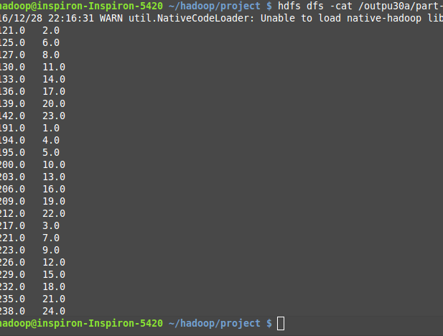
Screenshot for Step 2 to 5:
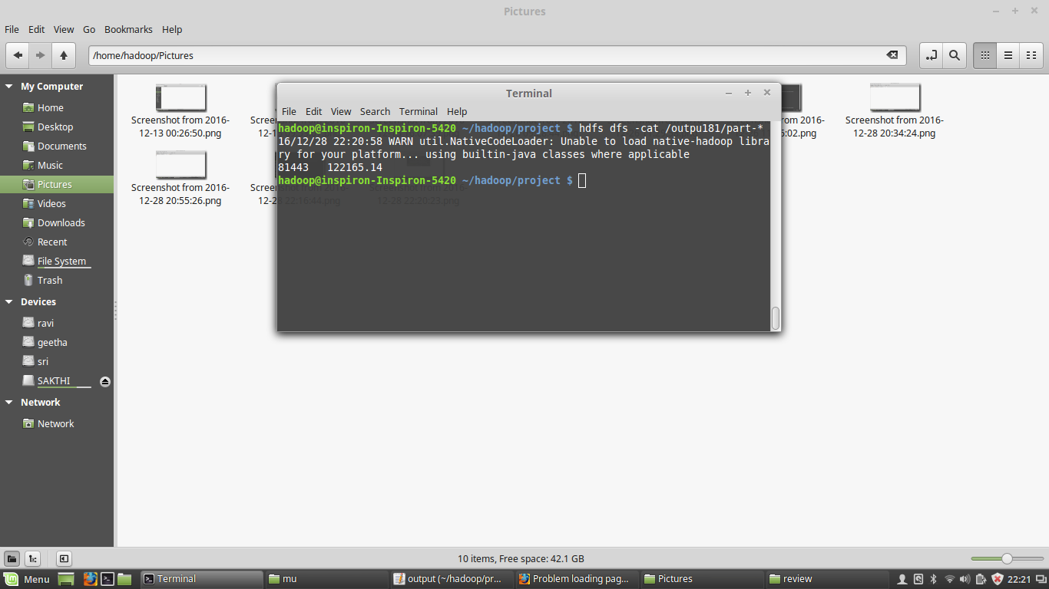
Screenshot for Step 6 to 9:
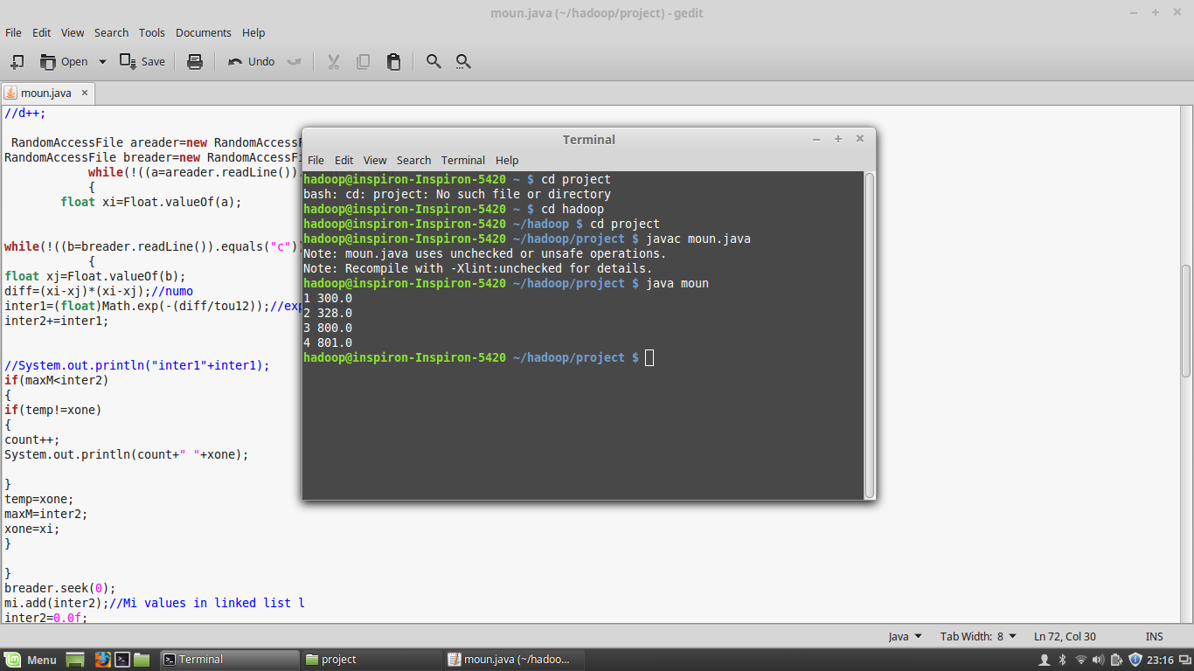

- RESULTS AND DISCUSSIONS
  - PERFORMANCE ANALYSIS

The Semantic Driven Subtractive Clustering algorithm is executed on a single node. Then it is executed parallely on two and three nodes.
This analysis shows that parallel SDSCM is must faster than SDSCM executed on single node.
Also, the number of iterations of k-means algorithm has comparatively decreased due to introduction of SDSCM.
- Time taken for clustering in single node - 21 seconds
- Time taken for clustering in two nodes - 12 seconds
- Time taken for clustering in three nodes - 7 seconds

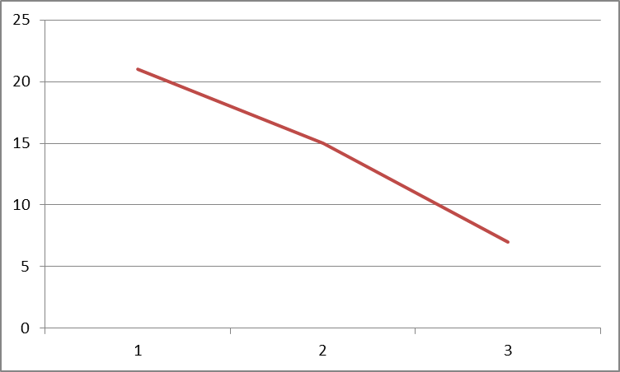
Execution time in seconds
Number of nodes

CONCLUSION

CONCLUSION AND FUTURE WORK

The implemented algorithm can be used to predict the customer churn of service industries where the data is in size of terabytes. Therefore, the company can design specific marketing strategies for obtaining higher profit. SDSCM improves clustering accuracy of SCM and k-means. Moreover, it decreases the risk of imprecise operations management using AFS. Experiment results indicate that SDSCM has stronger clustering. We modify the earlier serial SDSCM to big data SDSCM and implement it with a MapReduce framework. We solve the customer churn problem in China telecom with big data SDSCM and big data kmeans algorithms. The process of solving customer churn problem in Telecom has offered novel insights for managers to raise the level of customer churn management in the big data context.
In future, fuzzy k-means shall be implemented instead of k-means. Since, fuzzy means is based on the concept of soft clusters, it tells the probability of a data point to each cluster.

REFERENCES

REFERENCES

- Hadden, A. Tiwari, R. Roy, and D. Ruta, “Computer assisted customer churn management: State-of-the-art and future trends,” Comput. Oper. Res., vol. 34, no. 10, pp. 2902–2917, Oct. 2007. N. Lu, H. Lin, J. Lu, and G. Zhang, “A customer churn prediction model in telecom industry using boosting,” IEEE Trans. Ind. Informat., vol. 10, no. 2, pp. 1659–1665, May 2014.
- B. Q. Huang, T. K. Mohand, and B. Brian, “Customer churn prediction in telecommunications,” Expert Syst. Appl., vol. 39, no. 1, pp. 1414–1425, Jan. 2012.
- E. G. Castro and M.S.G. Tsuzuki, “Churn prediction in online games using players’ login records: A frequency analysis approach,” IEEE Trans. Comput. Intell. AI Games, vol. 7, no. 3, pp. 255–265, Sep. 2015.
- W. H. Au, K. C. C. Chan, and Y. Xin, “A novel evolutionary data mining algorithm with applications to churn prediction,” IEEE Trans. Evol. Comput., vol. 7, no. 6, pp. 532–545, Dec. 2003.
- K. J. Kohlhoff, S. P. Vijay, and B. A. Russ, “K-means for parallel architectures using all-preﬁx-sum sorting and updating steps,” IEEE Trans. Parallel Distrib. Syst., vol. 24, no. 8, pp. 1602–1612, Aug. 2013.
- C. Boutsidis and M. I. Malik, “Deterministic feature selection for kmeansclustering,”IEEETrans.Inf.Theory,vol.59,no.9,pp.6099–6110, Sep. 2013.
- F. Afsari, M. Eftekhari, E. Eslami, and P. Y. Woo, “Interpretability-based fuzzy decision tree classiﬁer a hybrid of the subtractive clustering and the multi-objective evolutionary algorithm,” Soft Comput., vol. 17, no. 9, pp. 1673–1686, Jan. 2013.
- A. Garcia-Piquer, A. Fornells, J. Bavardit, and A. Orriols-Puig, “Largescale experimental evaluation of cluster representations for multiobjective evolutionary clustering,” IEEE Trans. Evol. Comput., vol. 18, no. 1, pp. 36–53, Feb. 2014.
- A. Soualhi, C. Guy, and R. Hubert, “Detection and diagnosis of faults in induction motor using an improved artiﬁcial ant clustering technique,” IEEE Trans. Ind. Electron., vol. 60, no. 9, pp. 4053–4062, Sep. 2013. [22] J. Dean and S. Ghemawat, “MapReduce: Simpliﬁed data processing on large clusters,” Commun. ACM, vol. 51, no. 1, pp. 107–113, 2008.

